RECIPE  
Banana Bread

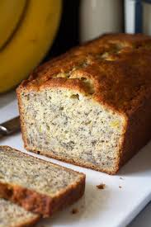

# Ingredients

* ½ cup shortening
* 1 cup sugar
* 2 eggs
* 1 ¼ cup flour
* ½ tsp salt
* ¾ tsp soda
* like ...6 banana

# Preparation

1. Combine ingredients
2. Pour into a greased and floured pan and cover with aluminum foil
3. Bake at 350 degrees for 1 hour